### **Test Summary Report**

### **by Mariia Mielnikova**

### **based on**

### **E2E testing, User Stories and Functional testing**

### **by Mihail Medvedev**

***Review date: 09.02.2024***

***Project name: SKYBOT***

**Step #1) Purpose of the document**

This document explains a summary report based on E2E testing scenarios and User Stories performed as part of the Testing process of the “SKYBOT”

**Step #2) “SKYBOT” Overview**

B2C portal for a company that sells and services electric vehicles under the brand name SKYBOT. Also, potential users could register on the portal and communicate with other Members. Every registered User will have personal profile and could manage it with different options

Link to the portal - <https://prometheusqastage3.wixsite.com/skybot>

**Step #3) Testing Scope**

A functionality verification of this webportal will be presented by different kinds of testing scenarios, User Stories and test cases, which were created earlier and will show full coverage of the main function and its possibilities.

In-scope:

* Registration
* Navigation
* Ordering
* Payment
* Exploring

**Step #4) Test summary**

* **Testing of customer requirements**

The requirements exhaustively describe the entire functionality of the system. All aspects that the system must fulfill are clearly documented. Each requirement is assigned an importance and priority to determine the priority of fulfillment by the development team.

* **Development of a test plan**

Test plan highlights all reqiered set of project elements that are necessary to

perform testing: agreed requirements, test environment readiness for test execution, test team readiness for test execution.

* **Initial testing of the initial version of the product**

The developed version of the portal passed the MVP (minimum viable product) test for compliance with customer requirements. Test scenarios have been developed and the site mockup has been checked for compliance with the requirements.

* **Creating a test coverage**

Created test coverage (test cases) in the environment according to the defined parameters. Main risks are identified and given special attention during testing. Established acceptance criteria for each test, for a clear metric for evaluating test results

* **Smoke testing of the portal (v.1)**

Necessary smoke tests for the build phase of the first version of the portal have been identified (Adaptability and compatibility testing; Configuration testing; Basic functionality testing)

* **Run tests and record results (v.2)**

Test cases are divided by complexity and priority. Test results, identified problems are logically documented, and test steps are described in detail

* **Functional testing of the portal (v.2)**

Functional test cases were developed with high precision, which describe in detail the sequence of actions, input data, and expected results to test certain functionality of the web portal. Each test case has a description of the test scenario, input data, execution steps, and expected results.

* **Non-functional testing of the portal**

In this block were used different valuable test cases for evaluating system attributes that are not related to the direct functionality of the product, such as: response time (using Postman), performance of the web portal, load testing (by simulate multiple concurrent users accessing), security (by checking valid SSL certificate).

* **Re-test and regression testing (v.3)**

The bug fixes were checked and the absence of new bugs after the fixes was checked. Test cases were executed that were related to bugs found or components that were changed. Regression tests have been performed using the defined test cases. The author investigated whether the existing functionality continues to work properly after the changes were made.

* **End-to-end testing before releasing the final version**

We developed test scenarios based on User Stories that covered the entire life cycle of interaction with the system, including data entry (authorisation), operations (searching products, adding to the cart), processing (payment), and output.

* **Acceptance testing in accordance with documentation and business needs**

Execute test scenarios according to the test plan. Confirmed that the system behaves as expected and satisfies the customer's or user's requirements and expectations. Errors and bugs are recorded and presented in a report

**Step #5) Metrics**

| **Test cases execute** | **Test cases passed** | **Test cases failed** | **Test cases not available for testing** |
| --- | --- | --- | --- |
| **284** | **180** | **49** | **55** |

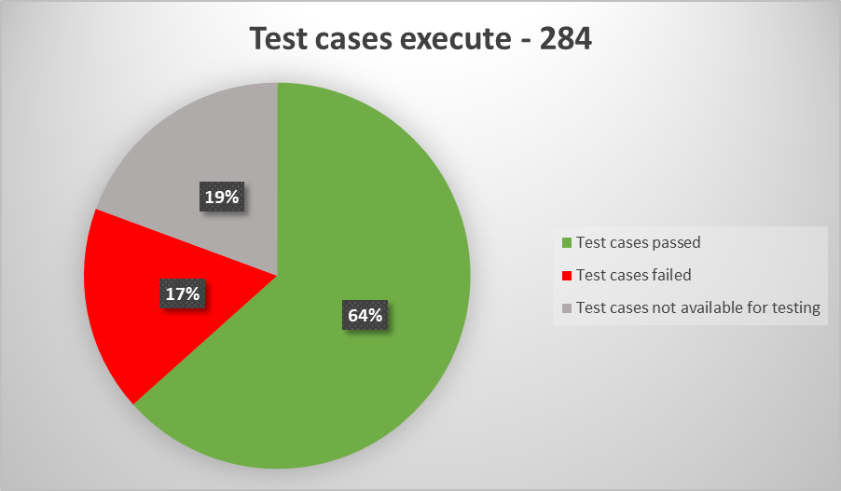

**Step #6) Environment**

OS: Windows 11 build 22H2,

Web browsers: Google Chrome version 121.0.6167.86, Mozilla Firefox version 122.0;

Mobile OS: Android 13,

Mobile browsers: Google Chrome version 120.0.6099.145, Mozilla Firefox version 121.0;

**Step #7) Exit criteria**

* All test cases that were planned are executed successfully
* All critical issues are closed
* Any other open issues have an action planned and are targeted for the next release cycle.

**Step #8) Conclusion**

The SKYBOT portal has been tested in all levels and using all possible tests that correspond to the latest build. User Story testing has covered different actions of potential Users. There are no critical issues that could interfere with the portal's operation. The application is suggested to be released to the end-users as all the requirements, quality standards are met. The application also shows no defects in the newly developed modules.

**Step #9) Sign Off**

***Verified by Mariia Mielnikova***